TASK 20:
Import java.util.*;

class Solution {
public int[] dailyTemperatures(int[] temperatures) {
int n = temperatures.length;
Deque<Integer> stk = new ArrayDeque<>();
int[] ans = new int[n];
for (int i = n - 1; i >= 0; --i) {
while (!stk.isEmpty() && temperatures[stk.peek()] <= temperatures[i]) {
stk.pop();
}
if (!stk.isEmpty()) {
ans[i] = stk.peek() - i;
}
stk.push(i);
}
return ans;
}
}
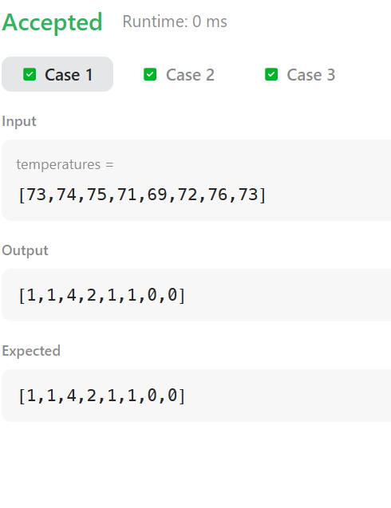
CASE 2:
Input
temperatures =
[30,40,50,60]
Output
[1,1,1,0]
Expected
[1,1,1,0]

CASE 3:
Input
temperatures =
[30,60,90]
Output
[1,1,0]
Expected
[1,1,0]

